**Engineering Notebook**

**Team 16 – Clear Path**

**Michael Yun**

**09/12/2024** - Team 16s first meeting and talk with customer, Dr. Towhidnejad. Scrumwise and Github established to start adding to backlog and documentation for the project. Division of skills between team members like Scrum-Master, Software, Hardware, and documentation. Stand up meeting to discuss the proposed objectives from customer and first steps taken.

**09/24/2024** - Teams first day in LB 131 with the flight simulator. Below is some of the information we gathered.

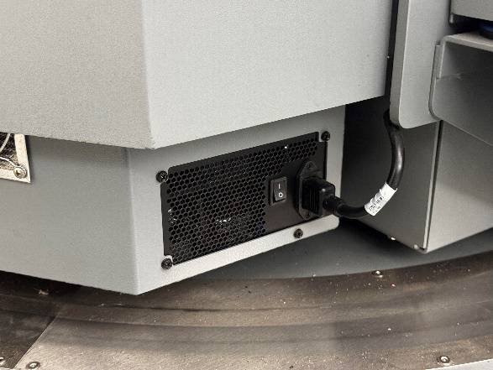

The white switch turns on the whole rig, and the smaller switch on the right side is now to turn the PC on.

There is a small red button below the seat on the right side, click the button one time for the green light to illuminate. Finally plug a wired keyboard into the hub on the right picture, follow the prompts on the screen and get to the home screen. From there we can use the wireless keyboard with mouse built in to navigate. We also uploaded any relevant text documents into our GitHub (<https://github.com/SadeedKhan555/ClearPath>).

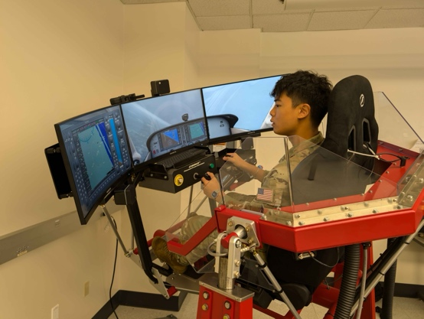

We got some time in on the simulator to see the different function, and displays within X-Plane.

10/15/2024 - Replacing Emergency stop button, part was ordered a week in advance install was slowed due to hurricane and campus closure. Images for button install are below. In addition, the peer reviews were completed by team members along with the sprint review presentation.

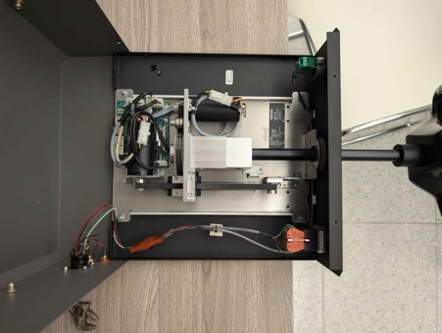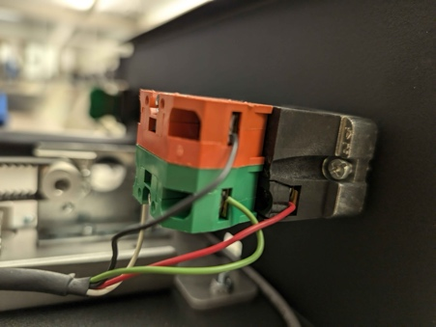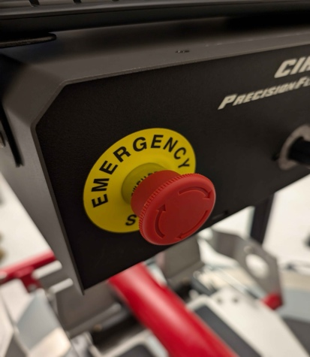

10/22/2024 - United Briefing; No work done

10/24/24 – Team meeting with student previously in charge of flight sim to ask questions related to start-up and uploading/inserting data into Xplane. Installation of graphics drivers to flight sim computer to start running XPlane 12. Sprint 3 finished; Items on backlog rearranged to reflect future project progress.

* Sprint obectived accomplished:
  + Meeting with student in charge of sim

11/5/24 – Worked on the update presentation. My job was to handle the results/progress section of the presentation.

11/12/24 – Our team worked on installing a plugin. However, we were not able to get any live traffic in it. We’re not exactly sure what this plugin does yet, but it didn’t break anything (fingers crossed)

11/14/24 – We started the poster. This was a significant day as we were able to successfully implement the plugin, granting us live traffic. There is more testing to be done, but this was a huge feat, and a major part of our program.

11/19/24 – We worked on the poster during this class. I was in charge of ensuring the graphics looked presentable, neat, and clean.

11/21/24 – Our group worked on version 2 of the SRS during this class. We divided up the work, but my job was to work on requirements.

11/26/24 – Heavily dedicated this class on finishing V2 of the SRS. My job was fixing all diagrams (use case, DFDs, context, etc).

11/28/24 – No class

12/3/24 – No coding, just working on deliverables. I worked on the presentation, recording the 10 minute video while Isacc and Cannon worked on the test plan.

1/9/2025 – No work done on the project except for setting up sprint 1. Met in ICI 101 and discussed future work for this semester

1/14/2025 – I conducted research on incursions, Sadeed and Isacc researched different plugins we can use, and Cannon worked on documentation for our SRS final version. We got stationary objects in place and now will be focusing on getting them moving

RESEARCHED WHAT CONSTITUTES ‘INCURSION’

1/21/2025 – We met with students from the French Air Force Academy this day. We were giving a demonstration of our flight simulator. We also planned out our next sprint and looked into pathing for our runways

1/28/2025 – We installed the RAAS plugin, making our sim more realistic. This is a real system used by pilots to prevent runway incursions

1/30/2025 – We are looking into plugins that allow us to better control the AI planes. This will allow us to eventually simulate incursion scenarios

2/4/2025 – Plugin research continued, SRS edited with diagrams

2/6/2025 – Plugin research continued, found location in plugin code that controls AI aircraft location X, Y, Z

2/11/2025 – Working on plugin still, also adjusting engineering notebook and peer feedbacks

2/13/2025 – Sadeed and I worked on installing visual studio to start building plugins. We are facing lots of issues and continuing to try to debug. Cannon is commenting on future revisions for the SDD and Isacc is continuing to research spawning objects

2/18/2025 – Today Sadeed and I tried to work on the lua scripts, we could not figure it out so we took a break. Isacc is currently working on instlling the python plugin that we are going to edit and Cannon is working on the SDD.

2/20/2025 – Today Sadeed and Isacc mainly worked on spawing a dynamic object. Thomas provided us with a plugin that helps spawn an object in, and now we’re working on getting it to work correctly. Cannon worked on the SDD while I worked on fixing our sprints to submit agile check 1.

2/25/2025 – We talked to Dr. T and Raj regarding chaleneges in our project. We are looking into more things we can do instead of runway incursion

2/27/2025 – Today we came up with some ideas to add on to our simulator instead of runway incursion. These are METAR and ATC integration

3/4/2025 – Today the team talked to Dr. T and Dr. Yang about the changes to our project. We pitched our idea and got the approval to move forward with METAR and ATC

3/6/2025 – Today we researched METAR and ATC plugin options and narrowed down the best route for both

3/18/2025 – Today we successfully installed the METAR plugin. We are having trouble syncing with realtime

3/20/2025 – Today we fixed the METAR plugin. We insured that it synced with real time weather

3/27/2025 – Missed class due to ROTC requirement

4/8/2025 – Today was spent finalizing the poster and getting approval from Dr. T and Raj.

4/10/2025 – Today we spent the day recording the video for our final video

4/15/2025 – Today was spent similar to the day prior; recording videos for the presentation video.

4/17/2025 – Today we recorded the final presenation video. We will now be editing the video and put it together for submission.

4/22/2025 – Today we are doing final submissions for feedback, egr notebook, etc